# **Name: Abdurrahman Qureshi**

# **Roll No: 242466**

Practical No: 6

**1) Write a python program to create a tuple having numbers till 20. Print half of its values in 1 line and another half in the next line.**

CODE:

numbers = tuple(range(1, 21))

half = len(numbers) // 2

print("First Half:", numbers[:half])

print("Second Half:", numbers[half:])

OUTPUT:

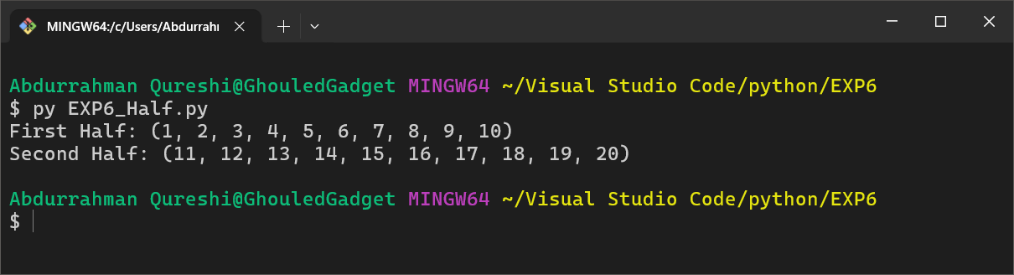

**2) Write a python program to create a tuple having all numbers from 1 to 100. Now create another tuple whose values are even numbers in the first tuple.**

CODE:

numbers = tuple(range(1, 101))

even_numbers = tuple(num for num in numbers if num % 2 == 0)

print("Even Numbers Tuple:", even_numbers)

OUTPUT:

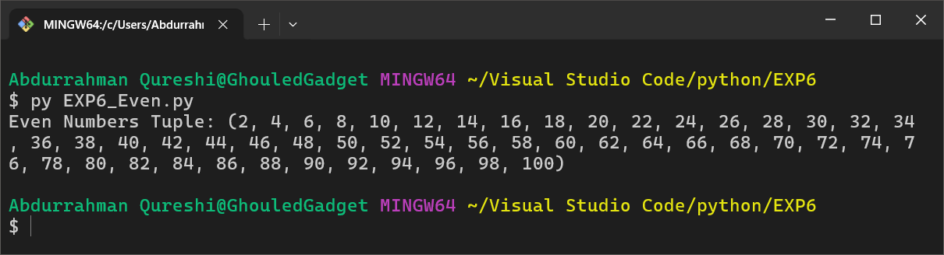

**3) Write a python program to concatenate two tuples.**

CODE:

tuple1 = (1, 2, 3)

tuple2 = (4, 5, 6)

concatenated_tuple = tuple1 + tuple2

print("Concatenated Tuple:", concatenated_tuple)

OUTPUT:

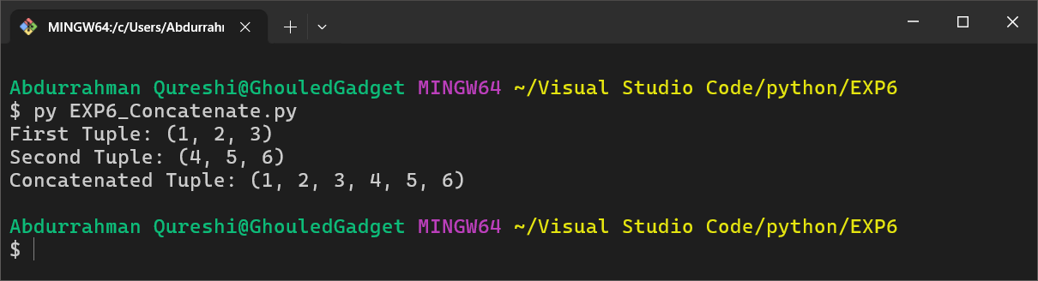

**4) Write a python program to accept elements in the form of tuple and display their sum and average.**

CODE:

numbers = tuple(map(int, input("Enter numbers separated by space: ").split()))

sum_values = sum(numbers)

avg_value = sum_values / len(numbers)

print("Sum:", sum_values)

print("Average:", avg_value)

OUTPUT:

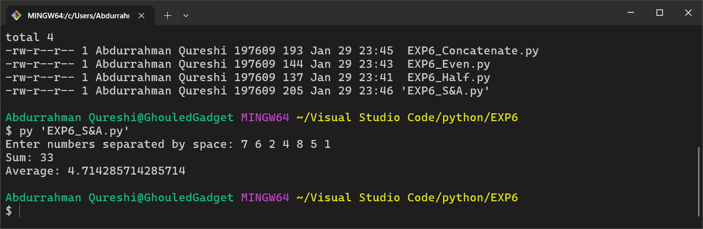

**5) Write a python program to find the first occurrence of an element in a tuple.**

CODE:

numbers = (10, 20, 30, 40, 50, 30, 60, 70)

search_element = 30

index = numbers.index(search_element)

print(numbers)

print(f"First occurrence of {search_element} is at index {index}")

OUTPUT:

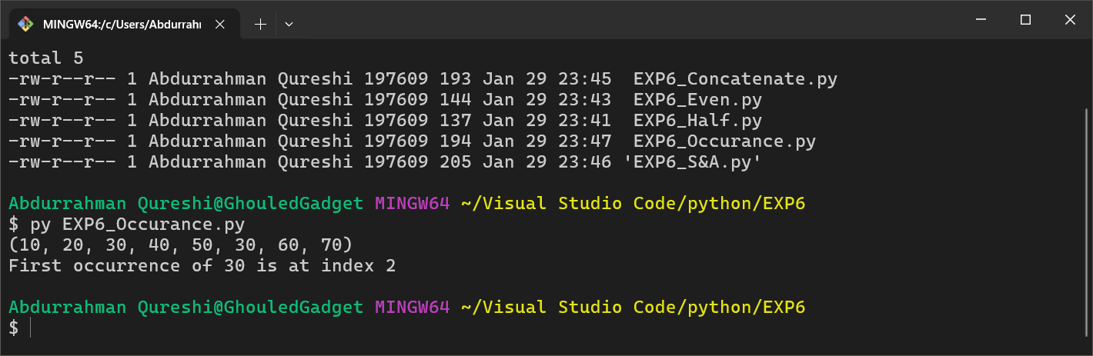

**6) Write a python program to pickle List, dictionary, tuple and string.**

CODE:

import pickle

data = {

    "list": [1, 2, 3, 4, 5],

    "dict": {"name": "qarq90", "age": 20},

    "tuple": (10, 20, 30),

    "string": "Death is an old friend"

}

with open("data.pkl", "wb") as file:

    pickle.dump(data, file)

print("Aachaar is ready to serve")

OUTPUT:

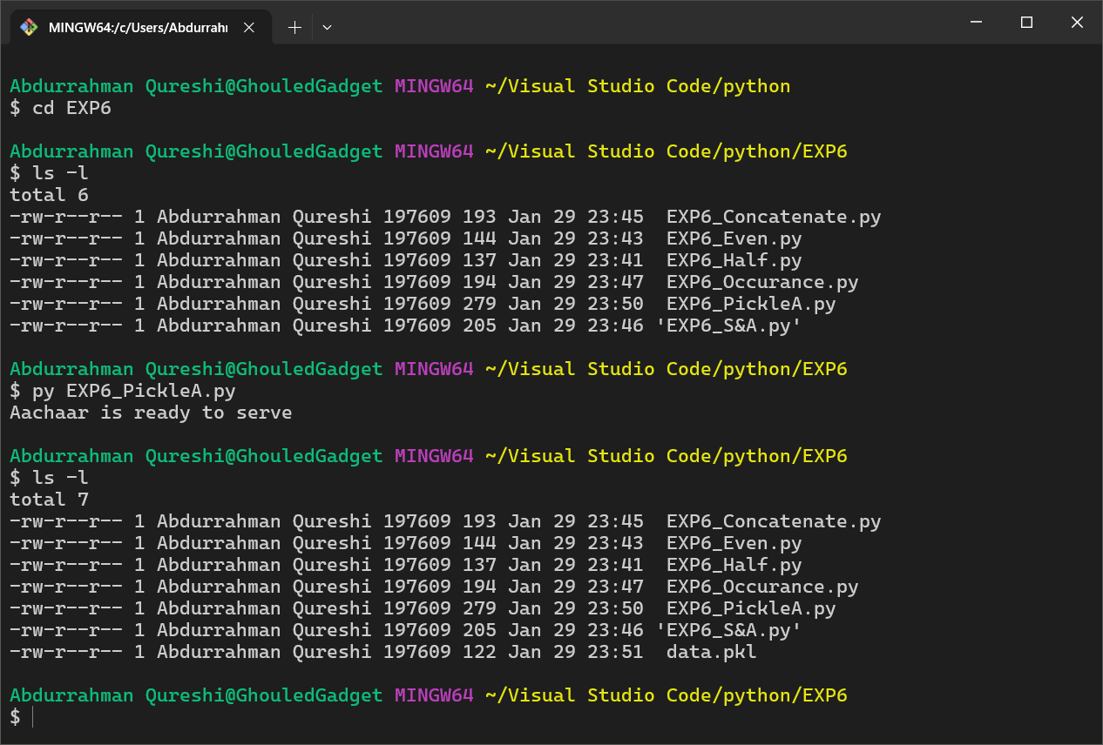

**7) Write a python program to demonstrate 2 methods of the tuple.**

CODE:

numbers = (10, 20, 30, 40, 50, 30, 60, 30)

print(numbers)

print("Count of 30:", numbers.count(30))

print("Index of 40:", numbers.index(40))

OUTPUT:

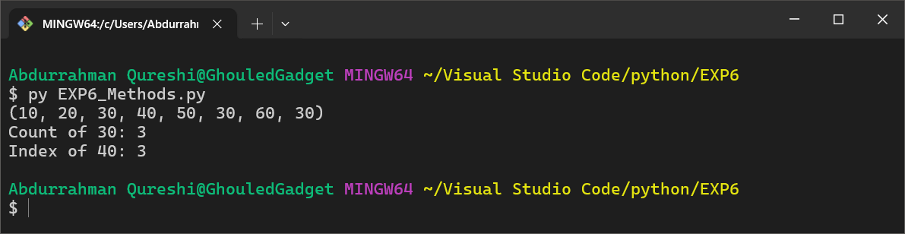

**8) Write a python program to demonstrate 5 methods of set.**

CODE:

my_set = {1, "2", 3.6, "Black People", "Hee hee haa"}

my_set.add(6)

print("Set:", my_set)

my_set.remove(3.6)

print("Set:", my_set)

my_set.discard(500)

print("Set:", my_set)

popped_element = my_set.pop()

print("Set:", my_set)

my_set.clear()

print("Set:", my_set)

OUTPUT:

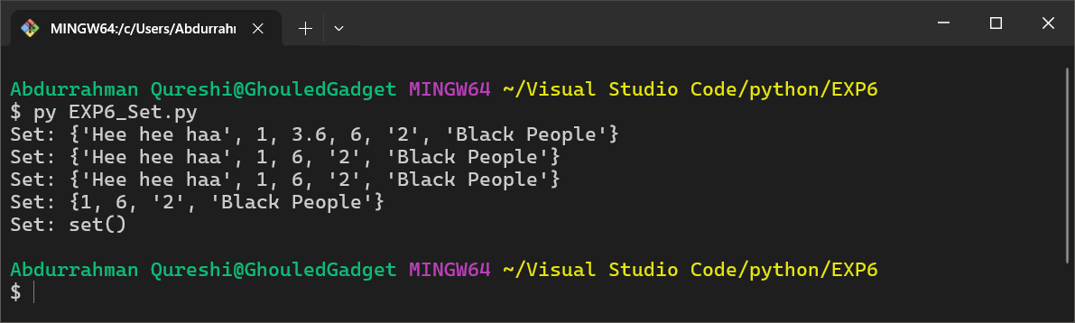

9) Write a python program to pickle tuples and strings.

CODE:

import pickle

data = {

    "tuple": (100, 200, 300),

    "string": "Aachar this string!"

}

with open("aachar.pkl", "wb") as file:

    pickle.dump(data, file)

print("Tuple and String have been aachaared successfully.")

OUTPUT:

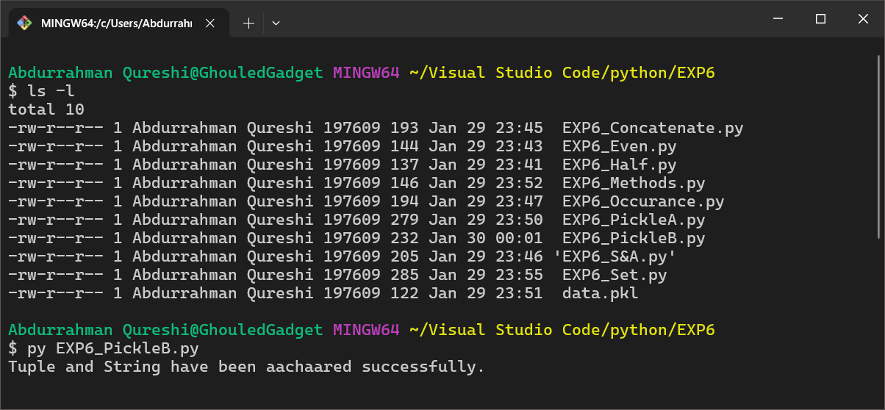

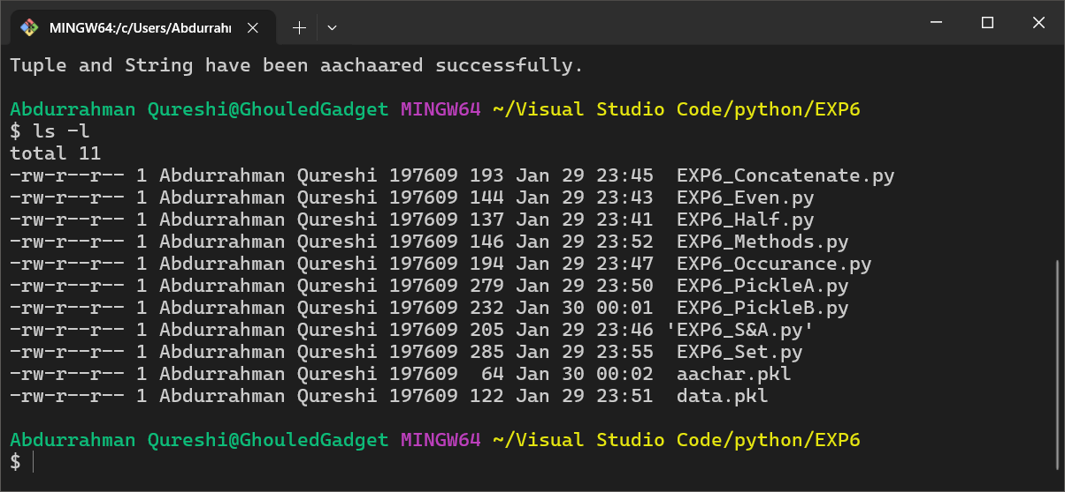

**10) Write a python program to implement snake ladder game using python dictionary**

CODE:

import time

import random

import sys

SLEEP_BETWEEN_ACTIONS = 1

MAX_VAL = 100

DICE_FACE = 6

snakes = {

17: 7,

54: 34,

62: 19,

64: 60,

87: 36,

95: 75,

93: 73,

98: 79,

}

ladders = {

4: 14,

9: 31,

1: 38,

21: 42,

28: 84,

51: 67,

72: 91,

80: 99

}

def welcome_msg():

msg = "Welcome to Snake and Ladder Game"

print(msg)

def get_player_names():

player1_name = input("Please enter a valid name for first player: ").strip()

player2_name = input("Please enter a valid name for second player: ").strip()

print("\nMatch will be played between '" + player1_name + "' and '" + player2_name + "'\n")

return player1_name, player2_name

def get_dice_value():

time.sleep(SLEEP_BETWEEN_ACTIONS)

dice_value = random.randint(1, DICE_FACE)

print("Its a " + str(dice_value))

return dice_value

def got_snake_bite(old_value, current_value, player_name):

print("\n" + "Snake Bite" + " ~~~~~~~~>")

print("\n" + player_name + " got a snake bite. Down from " + str(old_value) +" to " + str(current_value))

def got_ladder_jump(old_value, current_value, player_name):

print("\n" +"Woww , nailed it" + " ########")

print("\n" + player_name + " climbed the ladder from " + str(old_value) + " to " + str(current_value))

def snake_ladder(player_name, current_value, dice_value):

time.sleep(SLEEP_BETWEEN_ACTIONS)

old_value = current_value

current_value = current_value + dice_value

if current_value > MAX_VAL:

print("You need " + str(MAX_VAL - old_value) + " to win this game. Keep trying.")

return (old_value)

print("\n" + player_name + " moved from " + str(old_value) + " to " + str(current_value))

if current_value in snakes:

final_value = snakes.get(current_value)

got_snake_bite(current_value, final_value, player_name)

elif current_value in ladders:

final_value = ladders.get(current_value)

got_ladder_jump(current_value, final_value, player_name)

else:

final_value = current_value

return final_value

def check_win(player_name, position):

time.sleep(SLEEP_BETWEEN_ACTIONS)

if MAX_VAL == position:

print("\n\n\nThats it.\n\n" + player_name + " won the game.")

print("Congratulations " + player_name)

print("\nThank you for playing the game. Hope you enjoyed the game\n\n")

sys.exit(1)

welcome_msg()

time.sleep(SLEEP_BETWEEN_ACTIONS)

player1_name, player2_name = get_player_names()

time.sleep(SLEEP_BETWEEN_ACTIONS)

player1_current_position = 0

player2_current_position = 0

while True:

time.sleep(SLEEP_BETWEEN_ACTIONS)

input_1 = input("\n" + player1_name + ": " + " Hit the enter to roll dice: ")

print("\nRolling dice...")

dice_value = get_dice_value()

time.sleep(SLEEP_BETWEEN_ACTIONS)

print(player1_name + " moving....")

player1_current_position = snake_ladder(player1_name, player1_current_position, dice_value)

check_win(player1_name, player1_current_position)

input_2 = input("\n" + player2_name + ": " + " Hit the enter to roll dice: ")

print("\nRolling dice...")

dice_value = get_dice_value()

time.sleep(SLEEP_BETWEEN_ACTIONS)

print(player2_name + " moving....")

player2_current_position = snake_ladder(player2_name, player2_current_position, dice_value)

check_win(player2_name, player2_current_position)

OUTPUT:

